- For new articles, verify that there is not an existing article that covers this information or one that can be updated to include this information.
- Verify that this article is exclusive to one product (DonorView or AssociationSphere) OR ensure the corresponding article has been created/edited for the other product.
- For articles that cover both products, ensure that the appropriate terminology is applied to the article (for example DonorView has a Gifts grid, whereas AssociationSphere has a Transactions grid.)
- If the article includes a numbered or bulleted list of features, ensure they are shown in the same order as they are shown in the software.
- Proof-read and spell-check the article. Be sure to check for unnecessary capitalization. Only capitalize proper nouns. For example, “There are many constituents on the Constituents Grid.” “Constituents Grid” is a proper noun, and “constituents” is not.
- For complex subjects or topics ask a subject-matter expert to review the article before publishing.
- Ensure that the article is placed in the appropriate category and folder.
- To indicate an action or a specific button or link, you can either use quotes or bolding to make it clear that is an action the user must take. For example, “Click on the Update button to save your work.” Or “ Click on the “Update” button to save your work.” Using the bold feature makes the activity stand out.
- Use links only when necessary, excessive links in an article can lead to problems as the article ages with links moving, changing, or being removed. Everyone hates the “404 Error – Not Found” page from a broken link.
- If you are editing an article, verify all the old links in the article work.
- Set up links to open in a new tab.
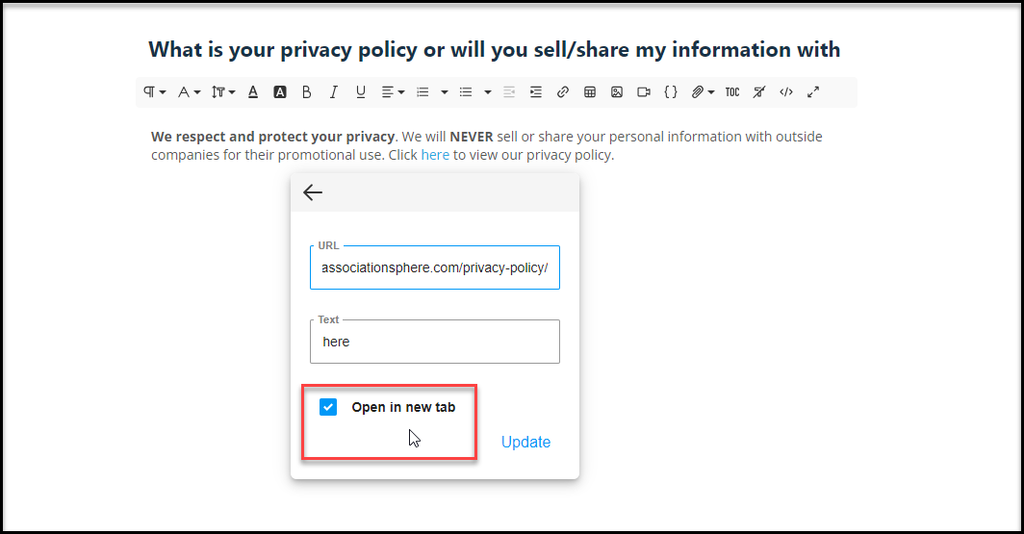
- Include screenshots whenever possible. The screen shot should be directly below the associated text.
- Screenshots should include enough detail of the workspace so that a new, inexperienced user would be able to locate that button, link, or function easily. Zooming in too tightly can make it difficult for a new user to understand where that is located on the page.
- Images included in the articles should include a border. If your image does not have a border you can add one in the Edit mode for an article by clicking on the image, then clicking on the Magic Wand, and selecting Bordered. This helps to enhance readability.
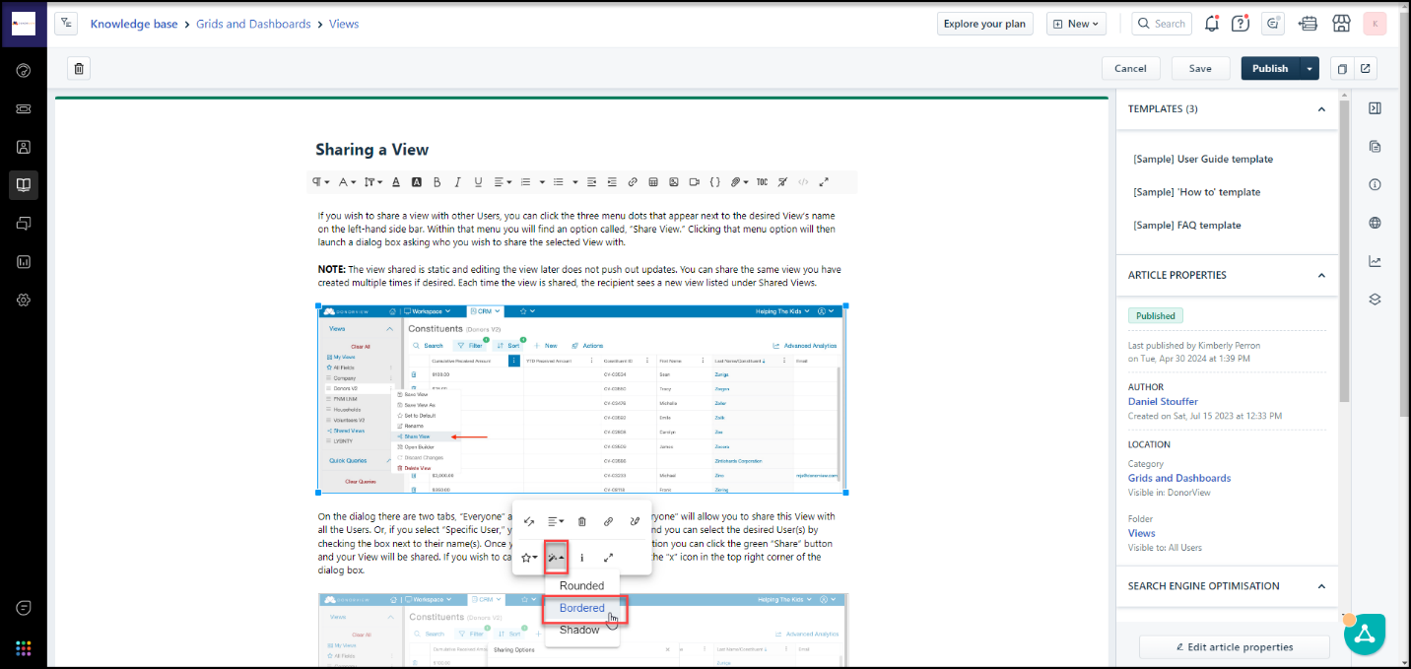

- After saving or publishing, open the link using the View on Portal icon in the top right of the article to ensure the article looks correct, links work, and images are legible. Sometimes when copy/paste is used to insert text and images, the published text and images are not aligned correctly due to hidden formatting and needs to be corrected.
